## Problem

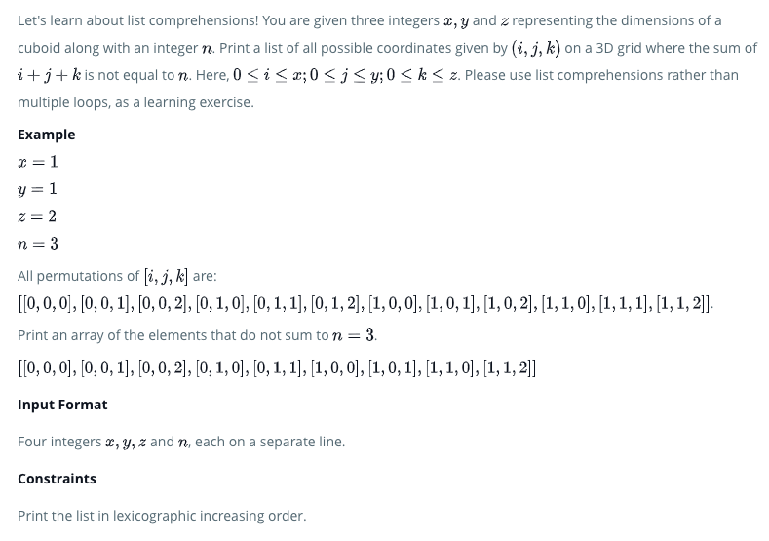

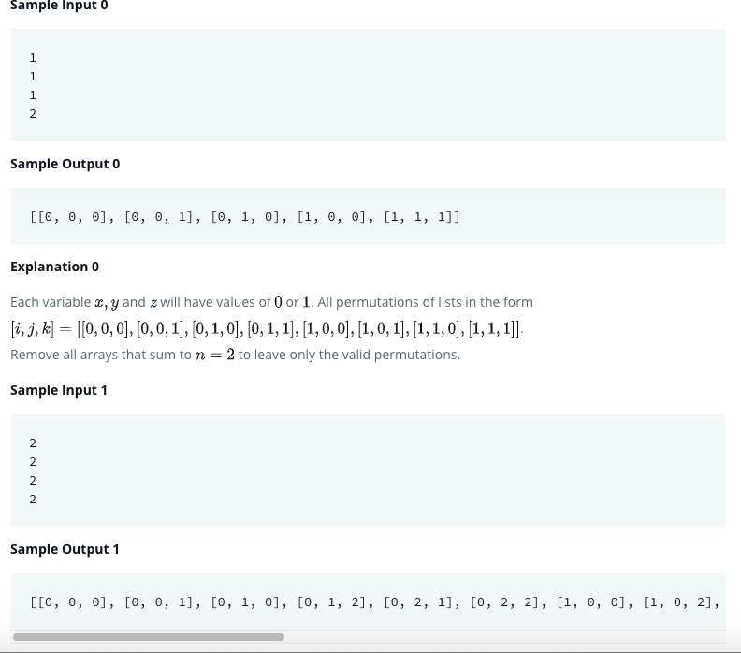

## Solution

if __name__ == '__main__':

    x = int(raw_input())

    y = int(raw_input())

    z = int(raw_input())

    n = int(raw_input())

lst = []

for i in range(0,x+1):

    for j in range(0,y+1):

        for k in range(0,z+1):

            if i + j + k != n:

                my_list = [i,j,k]

                lst.append(my_list)

print(lst)

## Python3

x,y,z,n = [int(input()) for i in range(4)]

print([[i,j,k] for i in range(x+1) for j in range(y+1) for k in range(z+1) if ((i+j+k) != n)])